Dear Community Partner,
PJ Parkinson’s Support Group  P.O. Box 641  Alcoa, TN 37701  865-268-5588  PJparkinsonsgroup@gmail.com  PJparkinsons.com | 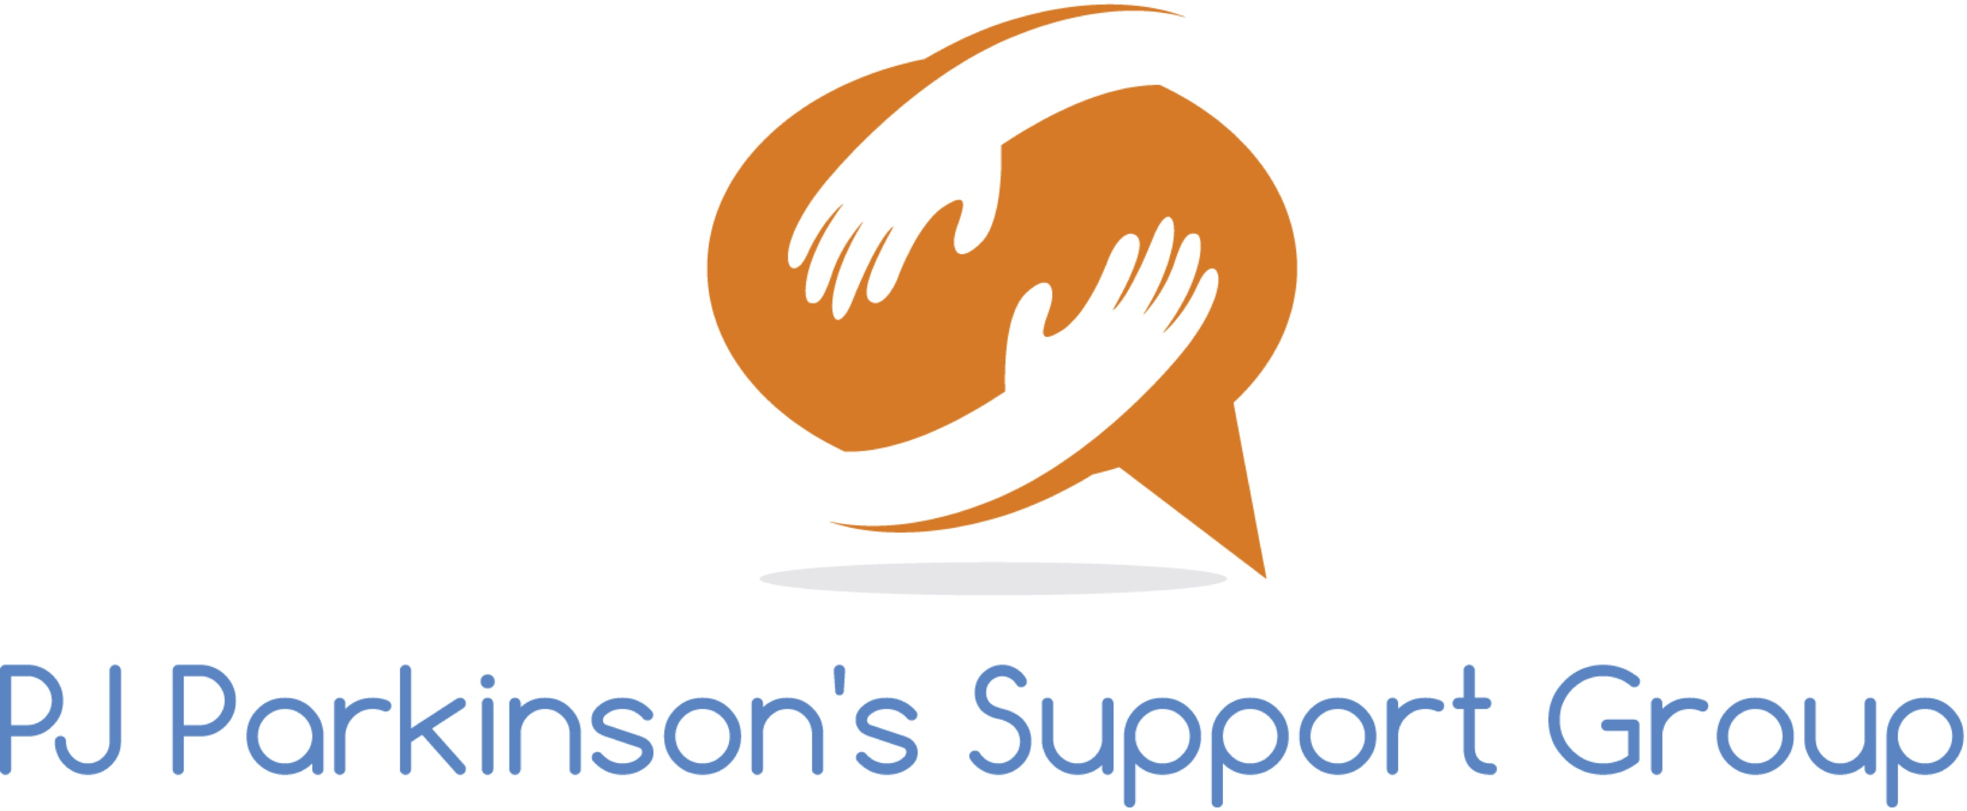

The incidence of Parkinson’s disease is on the rise in the United States, and Blount County is no exception.
There is no cure for Parkinson’s disease, but vigorous research is underway and promising new therapies are being developed that can help patients live longer, more active lives.

A group of Parkinson’s patients, along with their care supporters, formed the PJ Parkinson’s Support Group in May 2015. We are a 501(c)(3) non-profit organization (#47-3918996) and have an ambitious agenda that includes:

● Providing information, encouragement, and therapeutic activities for Parkinson’s patients.

● Increasing awareness of the symptoms of Parkinson’s in medical and healthcare communities so that it can be diagnosed and treated at its earliest stages.

● Providing financial support for research and local grants for Parkinsonians in need

We need your help to achieve these goals. The PJ Parkinson’s Support Group is organizing our third annual Parkinson’s Awareness Walk-a-thon on September 29, 2018 at Greenbelt Park (behind the Courthouse). We are excited to have Dick Ray and Randy Boyd as our chairmen this year. Proceeds will be used to help increase the understanding of this life-altering condition and to provide on-going support for our Parkinson’s group members. Would you consider sponsoring the Walk-a-thon at one of these levels?

● $3000 Elite Sponsorship (see sponsor level form)
● $1500 Gold Sponsorship (see sponsor level form)
- $ 500 Silver Sponsorship (see sponsor level form)
- $150 Friends of PJ Parkinson’s

The need for Parkinson’s education is real and growing. We are working to raise awareness and to provide support for people with Parkinson’s in our community, but we can’t do it alone. Thank you so much for your support.

Sincerely,

Isabell Senft-Daniel
Vice President

