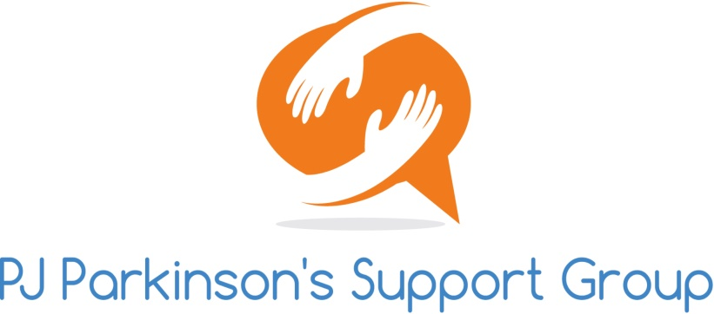 2018 PJ Parkinson’s Walk-A-Thon
Sponsorship Levels
Promote your Business! Saturday September 29, 2018

ELITE SPONSORSHIP $3,000
- Company Name/Logo on Event materials
- Company Sign along walk route
- Mention Name in various media outlets
- Company Logo on Event t- Shirt
- Company Sponsorship announced at Event
- Opportunity to distribute samples/brochures at your own booth or at walk site
GOLD SPONSORSHIP $1,500
- Company Name/Logo on Event materials
- Company Sign along walk route and on t-shirts
- Mention Name in various media outlets
- Company Sponsorship announced at Event
- Opportunity to distribute samples/brochures at walk site
SILVER SPONSORSHIP $500
- Company Name/Logo on Event materials
- Opportunity to display your own banner or sign along walk route
- Opportunity to distribute samples/brochures at walk site
Friend of PJ Parkinson’s $150
------------------------------------------------------------------------------------------------------------------------------------------
Company/Organization Name:____________________________________________________________
Company Contact Name:_________________________________________________________________
Address:______________________________________________________________________________
Email:_________________________________________________Phone:_________________________
Sponsorship Package:____________________________________Amount:________________________
Signature:_____________________________________________Date:___________________________
Please return this form with your donation & logo (per email to: isabellsenftdaniel@gmail.com)
PJ Parkinson’s Support Group of Blount County, P/O Box 641, Alcoa, TN 37701.

